Algorithm Programming Components

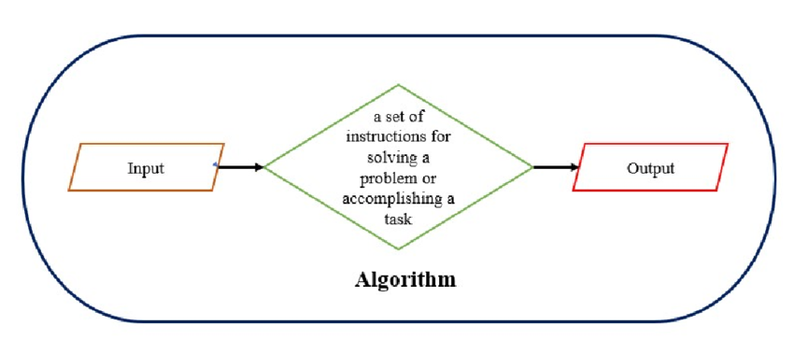

**Algorithms** are a set of well-defined instructions designed to solve a problem. In programming, algorithms are built using several fundamental components, each playing a specific role in defining logic and flow.

* **Key Components of an Algorithm:**

1. **Variables:** Store data that the algorithm processes.
2. **Conditions (Decision-Making):** Allow the algorithm to take different actions based on conditions.
3. **Loops (Iteration):** Repeat steps until a condition is met.
4. **Functions (Modularity & Reusability):** Encapsulate logic into reusable blocks.
5. **Input & Output (Interaction):** Allow communication with users or other systems.
6. **Data Structures (Organization):** Efficiently store and manipulate data.